# Supporting Information

*for*

**Material flows and GHG emissions from housing stock evolution in US counties, 2020-2060**

Peter Berrill1, Edgar G. Hertwich2

1Yale School of the Environment, New Haven CT, USA

2Norwegian University of Science and Technology, Trondheim, Norway

This document describes model development, data sources, methods, and demonstrates additional results for the research article “Material flows and GHG emissions from housing stock evolution in US counties, 2020-2060”.

## Development of stock model from AHS surveys

Metrics obtained from American Housing Survey (AHS) sample case history (US Census Bureau, 2017c) and general survey data (US Census Bureau, 2020a) for use in our model include:

* Annualized housing loss rates for combinations of housing type, age range, vacancy status, and US Census region
* Vacancy rates by housing type, Census region, and age cohort
* Annualized total and occupied housing stock growth
* Percent of addition and losses from new construction and demolition, respectively

American Community Survey (ACS) and Census population surveys supplement data from AHS, as described in the following subsections.

### Population and household size

We use the SSP2 scenario projection of county populations by Hauer (2019), which is the mid-range SSP projection, but is higher than the two scenarios most recently produced by the US Census Bureau (US Census Bureau, 2017a) (Fig. S1). We scale the SSP2 projection to the mid-range Census Bureau projection, and scale again to the actual population recorded on July 1, 2020 (US Census Bureau, 2020d). Initial estimates of household size in 2020 are calculated by house type and county, by dividing the 2019 population by house type in each county by number of occupied housing units in 2019. County population by house type is calculated by breaking county total population (US Census Bureau, 2020c) into house types using data from ACS table B25033 (US Census Bureau, 2021). The number of occupied housing units by house type in each county in 2019 is obtained from ACS Table B25127 (US Census Bureau, 2021).

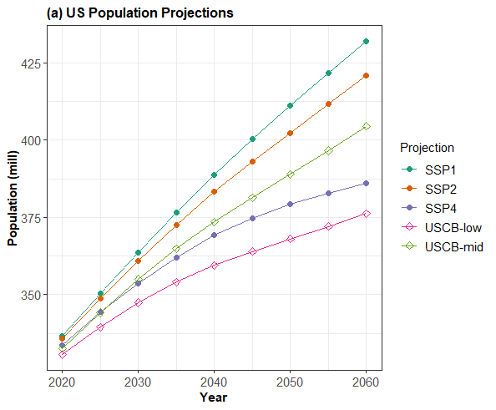 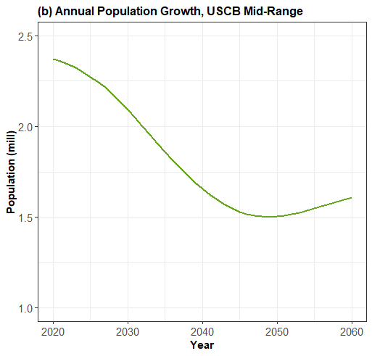

Figure S1 (a) US total population projection for three Shared Socioeconomic Pathways (Hauer, 2019) and USCB 2017 projections (US Census Bureau, 2017a), (b) Annual population growth, from the USCB Mid-Range scenario

Future changes in household size are estimated by extending household and population projections from McCue (2018). The data from McCue allow calculation of reductions in household size from 2018-2038. As estimations of housing stocks and flows based in part on household size are very sensitive to household size, we are conservative in extending these projections after 2038, beyond which we assume a very gradual decline in household size. In most scenarios (except for high multifamily scenarios), we apply the same relative reduction to all house types and counties. For instance, in Autauga County, Alabama, the average household size in 2020 in 2.67 in single-family, 1.81 in multifamily, and 2.52 in manufactured homes. Our household projections estimate that these values decline to 0.9645 of their 2020 value in 2060. Household sizes by house type in Autauga County in 2060 therefore become 2.58, 1.75, and 2.47 respectively. For the high multifamily scenarios, we project no change in household size by type, as reductions in average household size will naturally result from increases in population in multifamily housing, which has smaller household size than single-family housing. In 2020, the average household size by type is 2.88 in single-family, 2.69 in manufactured housing, and 2.13 in multifamily homes. In all scenarios, the national average household size among all house types falls from 2.67 in 2020 to 2.60 in 2060, but in the high-multifamily scenarios the decline is more gradual, as shown in Figure S2. Household size is calculated as the total resident population, including people living in group quarters - consistent with Hauer (2019), divided by the sum of occupied housing units.

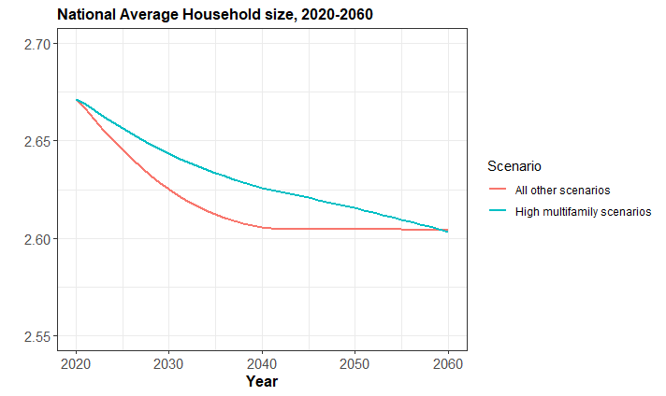

Figure S2 National average reduction in household size 2020-2060. Household size values implemented in our model equations are specific to house types and counties.

Figure S3 shows population projections for the four counties used for our demonstration of county level model outputs, demonstrating a range of population trajectories.

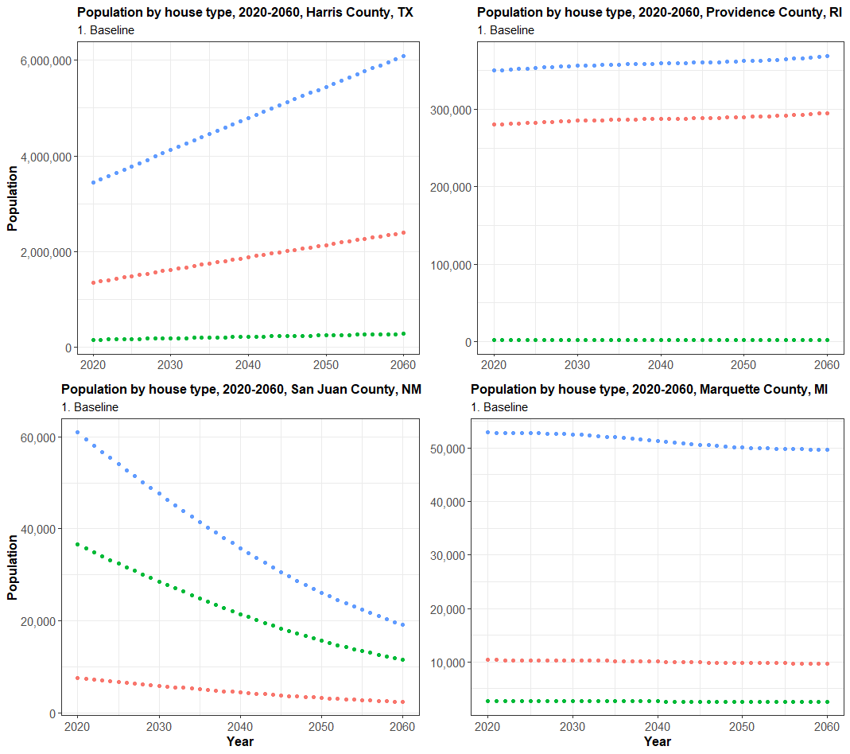 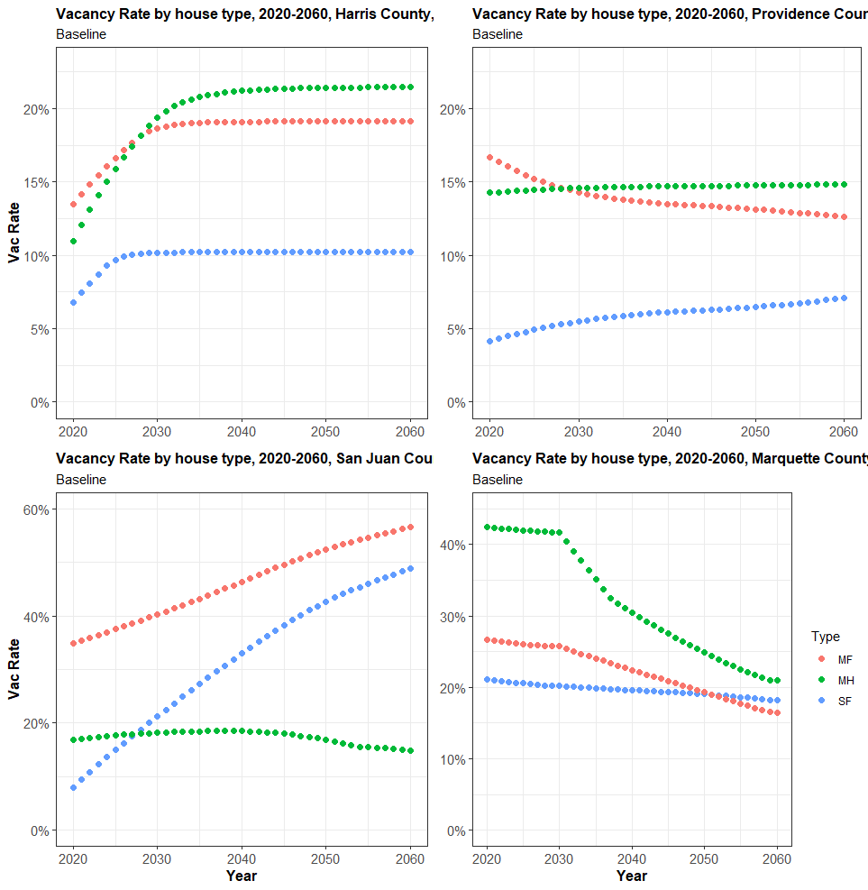

Figure S3 Population projections by house type for the counties of Harris TX, Providence, RI, San Juan, NM, and Marquette, MI.

### Loss rates by region, type, and age range

Loss rates (incorporating removal of housing from the stock for any reason, including demolition, use for non-residential purposes, falling into a state of disrepair which is unfit for habitation, and manufactured homes moving to different sites) are shown in Table S1 for housing by type, age range, and vacancy status. Generally, loss rates increase with age, and are much higher for vacant units than occupied units. Loss rates are also considerably higher for manufactured housing than for single- or multifamily. Generally, for both growing and declining housing stocks, losses from stock are calculated as shown in Eq. 2 of the main manuscript, using the given loss rates. In growing housing stocks, vacancies are kept at reasonable levels which tend to approach the natural rate as determined by Eq. 4. Because there is no representation of loss in the calculation of addition to stock for declining housing stocks (Eq. 1), it is possible for the model to produce infeasible vacancy rates (i.e. less than zero) in declining housing stocks. It is also possible for the vacancy rate to continually increase far above natural rates. To address these issues, we introduce clauses in the model to reduce loss rates if vacancies get too far below the natural rate (preventing vacancy rates from reaching zero or below), and to reduce addition rates if vacancies become much higher than the natural rates.

Table S1 Housing stock loss rates for single-family (SF), multifamily (MF), and manufactured homes (MH) by Census region, age range, and vacancy states (Occ = Occupied, Vac = Vacant), based on AHS data (US Census Bureau, 2017c)

|  |  |  |  |  |  |  |  |
| --- | --- | --- | --- | --- | --- | --- | --- |
| **Region** | **Type** | 0-19, Occ | 0-19, Vac | 20-59, Occ | 20-59, Vac | 60+, Occ | 60+, Vac |
| Northeast | SF | 0.18% | 0.20% | 0.39% | 1.00% | 1.42% | 2.63% |
|  | MF | 0.43% | 0.61% | 0.84% | 1.38% | 3.76% | 4.27% |
| Midwest | SF | 0.11% | 0.19% | 0.44% | 0.78% | 1.81% | 4.74% |
|  | MF | 0.26% | 0.53% | 1.44% | 0.56% | 3.09% | 5.13% |
| South | SF | 0.28% | 0.42% | 0.97% | 1.31% | 3.72% | 6.63% |
|  | MF | 0.35% | 0.88% | 1.93% | 0.89% | 3.06% | 5.96% |
| West | SF | 0.17% | 0.27% | 0.55% | 1.14% | 2.55% | 4.13% |
|  | MF | 0.27% | 0.63% | 1.19% | 1.06% | 2.53% | 3.24% |
| US | MH | 2.59% | 2.19% | 2.97% | 6.16% | 6.33% | 11.21% |

### Comparison of construction/addition, and demolition/losses.

We estimate the portion of additions to stock coming from sources other than new construction based on historical data varying by region and house type, summarized in Table S2. Similarly, we estimate the portion of losses to stock coming from sources other than demolition based on historical data shown in Table S3. For the model implementation, we estimate national average percentages for each house type, slightly higher than the data presented here, based on the assumption that in any given year, some housing which previously left the stock but was not demolished would be demolished.

Table S2 Percentage of additions to stock that comes from sources other than new construction, by types and region, based on AHS data (US Census Bureau, 2017c). SF = single-family, MF=multifamily, MH=manufactured homes

|  |  |  |  |
| --- | --- | --- | --- |
| **Region / Type** | SF | MF | MH |
| Northeast | 17% | 21% | 18% |
| Midwest | 15% | 21% | 21% |
| South | 14% | 19% | 21% |
| West | 11% | 13% | 24% |

Table S3 Percentage of losses that comes from demolition, by types and region, based on AHS data (US Census Bureau, 2017c)

|  |  |  |  |
| --- | --- | --- | --- |
| **Region / Type** | SF | MF | MH |
| Northeast | 23% | 12% | 41% |
| Midwest | 37% | 21% | 44% |
| South | 33% | 23% | 51% |
| West | 27% | 18% | 36% |

### Additions to stock under negative growth of occupied housing

In Figure S4, we illustrate near linear relations between stock addition rate (additions to stock divided by the total stock) and occupied stock growth (OSG) rate (increase in occupied housing divided by total stock) for single-family homes nationally, and in three Census Regions, based on AHS surveys 1973-2019 (US Census Bureau, 2017c, 2020a). What we wish to demonstrate here is that even in cases where OSG is negative (i.e. there is a reduction in the number of occupied housing units), stock addition rates can still be positive (new housing still gets built/added). In Table S4, we show the results of a liner model based on the same data to estimate addition rates based on OSG rates, for cases of negative OSF. These estimates of addition rates are used in Eq. 3 of the main manuscript.

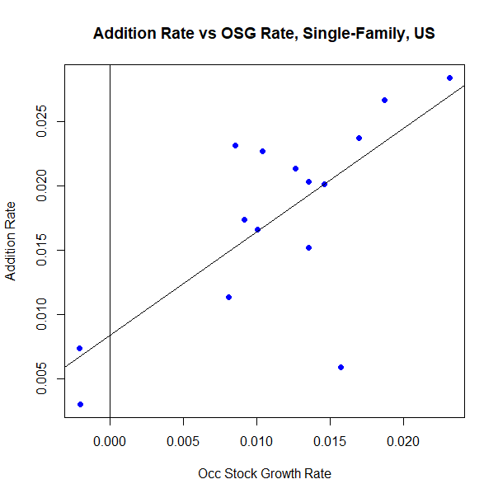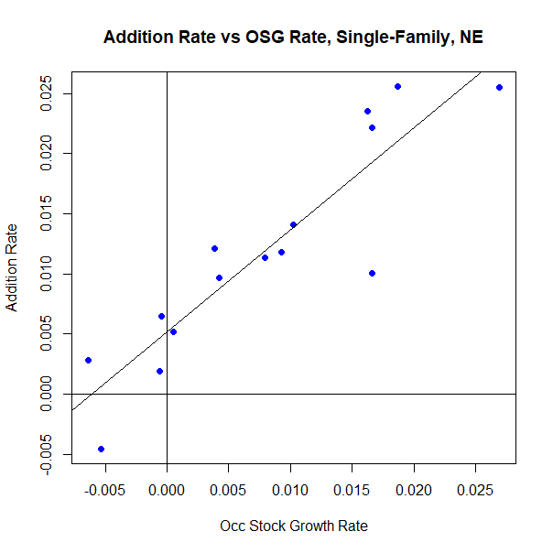

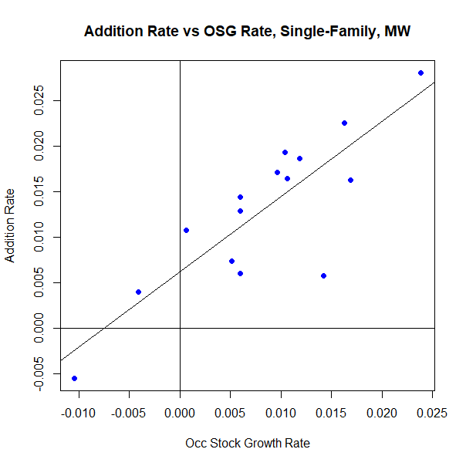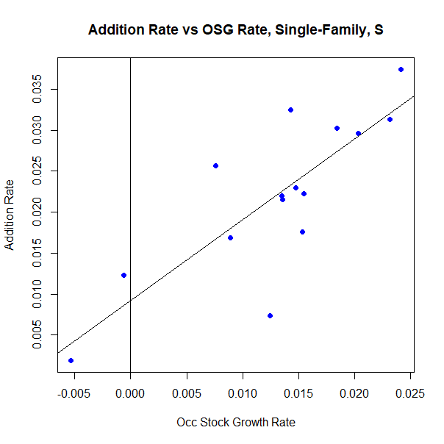

Figure S4 Stock addition rates vs occupied stock growth rates for single-family houses in the US and three Census regions. Even in times of negative occupied stock growth, it is usual to have a positive addition rate. Each observation corresponds to stock additions and stock growth between sucessive AHS surveys.

Table S4 Linear Models of Stock Addition Rate (AR) conditional on occupied stock growth (OSG) for three house types

|  |  |  |  |  |  |  |  |  |
| --- | --- | --- | --- | --- | --- | --- | --- | --- |
|  | *AR: SF* | | | *AR: MF* | | *AR: MH* | | |
| Intercept | 0.008* | (0.003) | 0.011*** | | (0.002) | 0.032*** | (0.005) |
| OSG: SF | 0.806** | (0.216) |  | |  |  |  |
| OSG: MF |  |  | 0.918*** | | (0.186) |  |  |
| OSG: MH |  |  |  | |  | 1.184*** | (0.239) |
| Observations | 15 |  | 15 | |  | 15 |  |
| R2 | 0.516 |  | 0.653 | |  | 0.653 |  |

*p <0.05, **p <0.01, ***p <0.001

### Estimation of stock growth factor based on changes in vacancy rates

In Figures S5-S7, we illustrate the relation between stock growth factors (*GF*) and changes in vacancy rates. *GF* is defined as the ratio of total stock growth to vacancy adjusted occupied stock growth (*OSG*) – i.e. *OSG* multiplied by the natural vacancy factor *VFn*.

(S1)

The change in vacancy from year to year is shown to be a strong predictor of *GF*, based on historical AHS data (US Census Bureau, 2017c, 2020a), and we use this relationship to estimate *GF* in our equation for calculating future additions to stock in cases of positive *OSG*, in Eq. 4 of the main manuscript. Regression equations are calculated only for cases of positive occupied and total stock growth, and for *GF* values lower than 2.5. In Eq. 4, predicted values of *GF* are limited to a lower bound 0.2 of and an upper bound of 1.3 for single-family and multifamily, and 1.4 for manufactured homes, to prevent the gap between observed and natural vacancy rates being closed too slowly or too quickly.

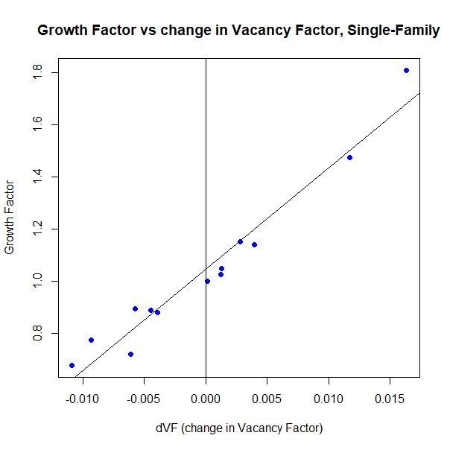 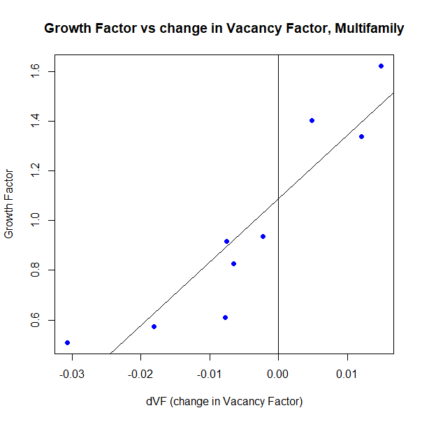

Figure S5 Regression equation: y = 38.9x + 1.046, R2 = 0.95. Figure S6 Regression equation: y = 25.5x + 1.086, R2 = 0.84.

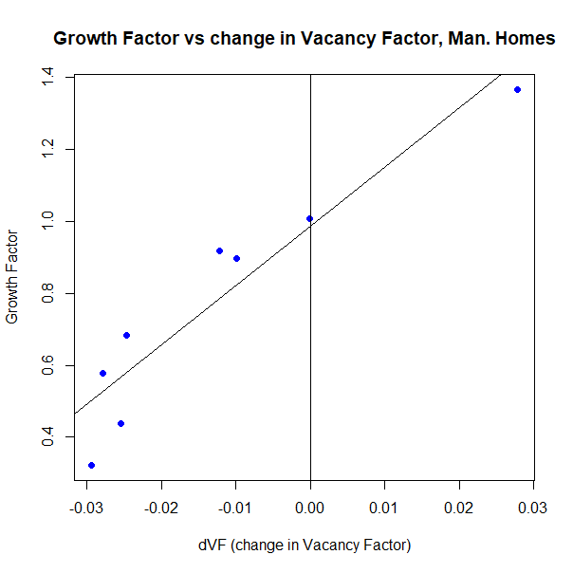

Figure S7 Regression equation: y = 16.4x + 0.985, R2 = 0.88.

### Historical vacancy rates by house type

To estimate initial vacancy rates by type and cohort by county, we use the sums of total stock by type and by cohort (separately) from ACS Table DP04, and use the estimates of occupied stock by type and cohort (nested) from B25127 to estimate nested total housing stock by type and cohort (US Census Bureau, 2021), and then combine the total stock and occupied stock estimates to calculate vacancy rates per house type and cohort for each county. RAS matrix balancing is used to produced balanced estimates of total housing stocks by type and cohort (Lenzen, Gallego, & Wood, 2009), using on the type-cohort distribution of occupied housing as a starting point. Note that the vacancy ratio calculated here is higher than the vacancy rates for rental and homeowner vacancy rates published by the Census Bureau, due to different definitions. The vacancy ratio that we calculate is the total number of units that were vacant at time of survey but fit for residential use (this excludes units that are damaged, or exposed to the elements, or housing units that are in use for non-residential purposes) divided by the total number of housing units fit for residential use. Our calculation includes vacant units that are held off market for temporary use or other reasons. In contrast, the rental and homeowner vacancy rates published by the Census Bureau only include units that are vacant for rent or for sale (US Census Bureau, 2017b).

In model projections, steps are taken to divide the total stock by each type into age cohorts and vacancy status, based on the propensity for different age groups to be occupied or vacant. For single family, we reduce the vacancy rate in the 11-30 age range by 0.5% and increase the vacancy rate in the 61+ age range by 0.5%. For multifamily, we increase the vacancy rate in the 0-10 age range by 0.5% and reduce the vacancy rate in the 31-60 age range by 0.5%. For manufactured homes, we reduce the vacancy rate in the 0-10 age range by 1.7% and increase the vacancy rate in the 31-60 age range by 1.7%. This represents filtering among households into the buildings that are more/less likely to be occupied based on what age group they fit into. In some cases this adjustment can produce an estimate of vacant units within a cohort that is higher that the total number of units in that cohort. In such cases, we reduce the magnitude of the adjustment, and if the discrepancy still remains, we remove this adjustment altogether. In Figure S8 we show national average vacancy rates and factors by house type calculated from AHS surveys 1985-2019. Average rates by Census region and house type were used to inform estimates of the natural vacancy rate by type for implementing Eq. 4 of the main manuscript.

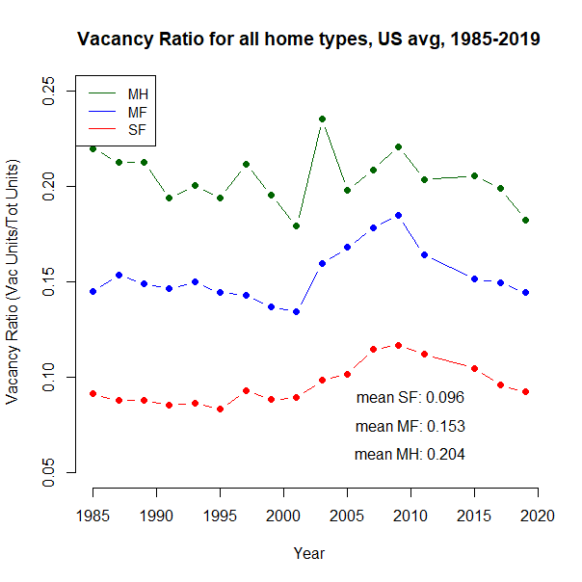 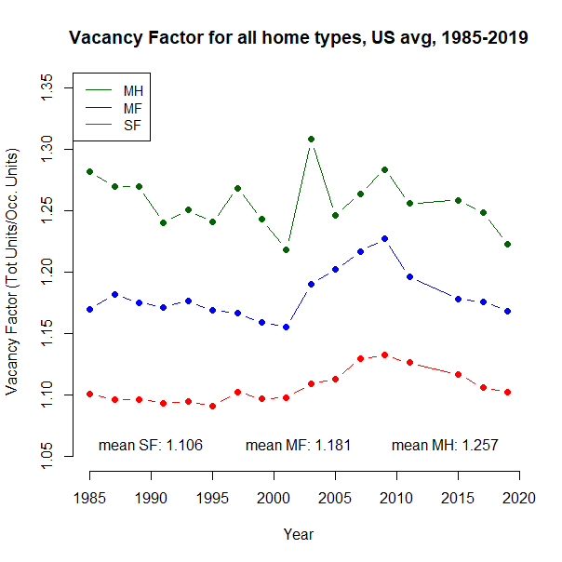

Figure S8 Historical trends and averages of vacancy rates and vacancy factors for three house types

## Floorspace estimates

For the initial housing stock in 2020, estimates of average floorspace per house type and cohort by county were produced by generating a large (180,000 housing units) representative sample of the US housing stock from the ResStock housing characteristics database (NREL, 2020b), using the Buildstock Batch sampling algorithm (NREL, 2020a). We calculate average floor area for type-cohort-county combinations with at least five sample points, and use averages of higher regional aggregations (State, Division, etc) to estimate county averages for combinations with less than five sample points. For new construction, we repeat this process using instead a 120,000 observation sample of new construction 2025-2060, with 15,000 samples for each five years 2025, 2030, etc. For high-multifamily and/or reduced floor area housing stock and characteristics scenarios, the floor area and housing type distributions which are fed into the sampling algorithm are changed depending on the scenario (Figure S14, S15).

## Archetype approach to material and GHG intensities

An archetype-based approach is used to calculate housing material and GHG intensities per unit floor area. These archetype intensities are used as the basis for estimating representative weighted average material intensities for construction and demolition, and GHG intensities for new construction, for each county and house type combination.

Fifty archetypes are designed using Athena Impact Estimator for Buildings, v5.4 (Athena Sustainable Materials Institute, 2020), and one archetype (#51) is based on a material inventory from literature (Reyna & Chester, 2015). Table S6 summarizes each archetype, defined by six dimensions describing different characteristics; foundation type, house type (single-family, multifamily, manufactured home), number of stories, presence of garage, size, and framing material. These dimensions are chosen based on their expected influence on material and GHG intensities. The floor area used in the denominator of intensity coefficients is m2 useful floor area (or “gross living area”), which excludes garages and basements (Fannie Mae, 2021).

Design details for slab, basement, and crawlspace foundations, including foundation depth and insulation type, location, and quantity, were based largely on information in the Foundation Design Handbook (Oak Ridge National Laboratory, 2013), alongside several additional resources (Concrete Network, n.d.; Holladay, 2014). Design of pier and beam foundations for single-family and manufactured homes benefited from the following sources (Model Manufactured Home Installation Standards, Subpart D - Foundations, 2001; Manufactured Housing Research Alliance, 2002). For mid-rise multifamily homes, we assumed a ‘podium’ framing design, in which a concrete framed ground storey sits below 3-6 timber frames stories. This is a very common approach for new mid-rise apartment construction (Cao, 2019; Fox, 2019). For high-rise multifamily, we did not create a new archetype design in Athena, but instead adopted the bill of materials presented for a 10-story concrete frame apartment building in Los Angeles (Reyna & Chester, 2015). For all single-family archetypes except those with crawlspace foundations, we designed four variants based on alternate choice of material for foundation insulation (polystyrene (EPS) or extruded polystyrene (XPS) for wood-frame home foundations, and polyisocyanurate or XPS in masonry home walls), and alternate choice of material for doors and window frames (glass fibre reinforced plastic or wood). For single-family homes with crawlspace foundations, we instead varied whether the crawlspace was vented or unvented, which influences the type, location and quantity of insulation material (Oak Ridge National Laboratory, 2013). For mid-rise multifamily and manufactured homes, we designed two variants based on alternative insulation material choice only. Material and GHG intensities for each archetype is based on the simple mean of the 2-4 archetype variants. These within-archetype design variants allowed us to capture some of the variation in material and especially GHG intensities of housing archetypes that can derive from material choices and other design decisions.

From the 48 unique material definitions which appear in the Athena bills of materials, we aggregate to 29 material product groups, for which we gather GHG intensities. These intensities are summarized in the ‘MatGHGInt.xls’ file on the github repository, with details on the source, geographical and temporal scope, and alternative intensities from literature. Depending on the material, the sources of material product GHG intensities are individual Environmental Product Declarations (EPDs), the ecoinvent database v3.5 (Wernet et al., 2016) - using the ReCiPe Midpoint (H) GWP 100a impact assessment method, the Inventory of Carbon and Energy v3.0 (Jones, 2019), or the implicit GHG intensity used in the Athena model. When choosing material GHG intensities, we aimed to use US-specific and the most recent data available, and in each case we choose the value which we felt best reflected current production methods in the US. For every material category, we assume a reduction in GHG intensity of material production between 2020 and 2060, reflecting improvements in material production efficiency and reductions in GHG intensity of energy supply. The baseline assumption is a reduction of 20% in 2060 compared to 2020. For individual materials which we believe will have lower or higher decarbonization potential, we use different reduction factors, and explain our assumption in the ‘2060 Assumption’ column. For wood based products, we assume no credit associated with energy use or biogenic carbon storage. To aid with presentation (Fig S15, S16) and interpretation, we again aggregate material and GHG emissions associated with each material type to 10 major material categories, and emissions from material transport to site/onsite energy use. GHG emissions from transport to site (life cycle stage A4) and onsite energy use (A5) are initially estimated from the LCA results provided by Athena. Compared to estimates of transport and site energy emissions per unit floor area from literature, the Athena estimates tend to be low (Table S7), and we therefore multiplied these emission intensities by a factor of 2, to address what appears to be underestimation of these emissions in Athena. We assume that the GHG intensity of emissions from site transport and energy use will reduce by 30% between 2020 and 2060. Summary material and GHG intensities for each archetype are available in the ‘Full_arch_intensities.csv’ file on the github repository.

Table S6 Descriptions and summary material intensity (MI) and GHG intensity (GI) values of each model archetype. UFA = Useable Floor Area, SF = Single-Family, MF = Multi-Family, MH = Manufactured Home

|  |  |  |  |  |  |  |  |  |  |
| --- | --- | --- | --- | --- | --- | --- | --- | --- | --- |
| **#** | **Foundation** | **Type** | **Stories** | **Garage** | **Size** | **Frame** | **Model UFA (m2)** | **MI (kg/m2)** | **GI (kgCO2e/m2)** |
| 1 | Slab | SF | One | Yes | Large | Wood | 279 | 616 | 176 |
| 2 | Slab | SF | One | No | Large | Wood | 279 | 527 | 153 |
| 3 | Slab | SF | One | Yes | Small | Wood | 130 | 774 | 233 |
| 4 | Slab | SF | One | No | Small | Wood | 130 | 616 | 191 |
| 5 | Slab | SF | Multiple | Yes | Large | Wood | 279 | 458 | 150 |
| 6 | Slab | SF | Multiple | No | Large | Wood | 279 | 378 | 128 |
| 7 | Slab | SF | Multiple | No | Small | Wood | 130 | 464 | 172 |
| 8 | Slab | SF | One | Yes | Large | Masonry | 279 | 910 | 256 |
| 9 | Slab | SF | One | No | Large | Masonry | 279 | 760 | 221 |
| 10 | Slab | SF | One | Yes | Small | Masonry | 130 | 1,232 | 355 |
| 11 | Slab | SF | One | No | Small | Masonry | 130 | 957 | 291 |
| 12 | Slab | SF | Multiple | Yes | Large | Masonry | 279 | 818 | 248 |
| 13 | Slab | SF | Multiple | No | Large | Masonry | 279 | 681 | 216 |
| 14 | Slab | SF | Multiple | No | Small | Masonry | 130 | 907 | 301 |
| 15 | Strip | MF | Multiple | No | Large | Podium | 150 | 308 | 115 |
| 16 | Strip | MF | Multiple | No | Small | Podium | 81 | 348 | 145 |
| 17 | Basement | SF | One | Yes | Large | Wood | 279 | 708 | 214 |
| 18 | Basement | SF | One | No | Large | Wood | 279 | 619 | 191 |
| 19 | Basement | SF | One | Yes | Small | Wood | 130 | 955 | 294 |
| 20 | Basement | SF | One | No | Small | Wood | 130 | 797 | 252 |
| 21 | Basement | SF | Multiple | Yes | Large | Wood | 279 | 533 | 172 |
| 22 | Basement | SF | Multiple | No | Large | Wood | 279 | 452 | 154 |
| 23 | Basement | SF | Multiple | No | Small | Wood | 130 | 606 | 213 |
| 24 | Basement | SF | One | Yes | Large | Masonry | 279 | 1,002 | 294 |
| 25 | Basement | SF | One | No | Large | Masonry | 279 | 852 | 259 |
| 26 | Basement | SF | One | Yes | Small | Masonry | 130 | 1,413 | 416 |
| 27 | Basement | SF | One | No | Small | Masonry | 130 | 1,138 | 352 |
| 28 | Basement | SF | Multiple | Yes | Large | Masonry | 279 | 892 | 274 |
| 29 | Basement | SF | Multiple | No | Large | Masonry | 279 | 755 | 242 |
| 30 | Basement | SF | Multiple | No | Small | Masonry | 130 | 1,050 | 343 |
| 31 | Crawlspace | SF | One | Yes | Large | Wood | 279 | 427 | 151 |
| 32 | Crawlspace | SF | One | No | Large | Wood | 279 | 337 | 128 |
| 33 | Crawlspace | SF | One | Yes | Small | Wood | 130 | 601 | 210 |
| 34 | Crawlspace | SF | One | No | Small | Wood | 130 | 444 | 168 |
| 35 | Crawlspace | SF | Multiple | Yes | Large | Wood | 279 | 362 | 135 |
| 36 | Crawlspace | SF | Multiple | No | Large | Wood | 279 | 302 | 118 |
| 37 | Crawlspace | SF | Multiple | No | Small | Wood | 130 | 361 | 155 |
| 38 | Crawlspace | SF | One | Yes | Large | Masonry | 279 | 721 | 231 |
| 39 | Crawlspace | SF | One | No | Large | Masonry | 279 | 571 | 197 |
| 40 | Crawlspace | SF | One | Yes | Small | Masonry | 130 | 1,059 | 333 |
| 41 | Crawlspace | SF | One | No | Small | Masonry | 130 | 785 | 268 |
| 42 | Crawlspace | SF | Multiple | Yes | Large | Masonry | 279 | 722 | 235 |
| 43 | Crawlspace | SF | Multiple | No | Large | Masonry | 279 | 585 | 203 |
| 44 | Crawlspace | SF | Multiple | No | Small | Masonry | 130 | 805 | 286 |
| 45 | Pier & Beam | SF | One | No | Large | Wood | 279 | 255 | 142 |
| 46 | Pier & Beam | SF | One | No | Small | Wood | 130 | 280 | 161 |
| 47 | Pier & Beam | SF | Multiple | No | Large | Wood | 279 | 196 | 109 |
| 48 | Pier & Beam | SF | Multiple | No | Small | Wood | 130 | 264 | 151 |
| 49 | Pier & Beam | MH | One | No | Large | Wood | 167 | 165 | 166 |
| 50 | Pier & Beam | MH | One | No | Small | Wood | 93 | 210 | 229 |
| 51 | Pile | MF | Multiple | No | Small | Masonry | 93 | 994 | 396 |

Table S7 Comparison of GHG emission intensities from transport to site (A4) and onsite construction energy (A5) from literature and from this study, before alteration

|  |  |  |  |
| --- | --- | --- | --- |
| **Source** | **Region** | **GHG Int. (kgCO2e/m2)** | **Description** |
| (Quale et al., 2012) | USA | 62 | Single-family home. Site energy use only |
| (Quale et al., 2012) | USA | 27 | Manufactured home. Site energy and transport to site |
| (Nadoushani & Akbarnezhad, 2015) | – | 14–29 | Multi-storey structures with varying framing material, number of stories, and lateral load resisting system |
| (Säynäjoki et al., 2017) | Finland | 34 | Mid-rise concrete apartment building, estimated using IO-LCA |
| (Säynäjoki et al., 2017) | Finland | 40 | Mid-rise concrete apartment building, estimated using process LCA |
| (Moncaster et al., 2018) | UK | 2–42 | Residential dormitory, concrete frame. Range based on assumptions re transport and site energy |
| (Moncaster et al., 2018) | UK | 2–40 | Residential dormitory, load-bearing masonry. Range based on assumptions re transport and site energy |
| (Moncaster et al., 2018) | UK | 6–67 | Residential dormitory, cross-laminated timber. Range based on assumptions re transport and site energy |
| (Moncaster et al., 2018) | UK | 2–36 | Residential dormitory, steel frame. Range based on assumptions re transport and site energy |
| (Petrovic et al., 2019) | Sweden | 24 | Wood-frame single-family home |
| (Dahlstrøm et al., 2012) | Norway | ~60 | Wood-frame single-family home |
| This study, unaltered | US | 13 | Single-family wood-frame, mean of 25 archetypes |
| This study, unaltered | US | 20 | Single-family masonry frame, mean of 21 archetypes |
| This study, unaltered | US | 12 | Manufactured Home, mean of two archetypes |
| This study, unaltered | US | 10 | Low-rise podium frame multifamily, mean of two archetypes |
| This study, unaltered | US | 32 | High-rise concrete frame multifamily |

In Figures S9 and S10 we show total emission intensities from material production and onsite transport and energy use for the 51 archetypes listed in Table S6. Inspection of Table S6 and Figures S9 and S10 reveals some patterns of GHG intensities of different archetypes. Between house types, the multifamily low-rise archetype has the lowest emission intensities, while the multifamily high-rise have the highest. For single-family foundation types, homes with pier-beam and crawlspace foundations have the lowest emission intensities. Homes with basement foundations tend to have the highest emission intensities. Wood frame homes tend to have notably lower emission intensities than masonry homes. Large homes (see the Model UFA column of Table S6 for the design useful floor area of each archetype model), and multifamily homes tend to have smaller emission intensities. This is likely due to a lower perimeter to floor area ratio in large homes and multi-storey homes – as the material quantities in the foundation and walls are highly influenced by the house perimeter. Larger homes are still likely to have higher total material requirements than smaller homes. These results suggest decisions that home designers and homebuyers can take to lower the material related emissions; building multi-storey for a given floor area (e.g. two stories of 100 m2 each rather than one storey with 200m2), and avoiding basement foundations or garages are all likely lower the embodied emissions of a home without increasing energy use. Although wood-frame homes have lower embodied emissions, their preference over masonry homes from a whole life-cycle perspective including energy related emissions is a more complex question (Heeren et al., 2015), which is outside the scope of the current analysis.

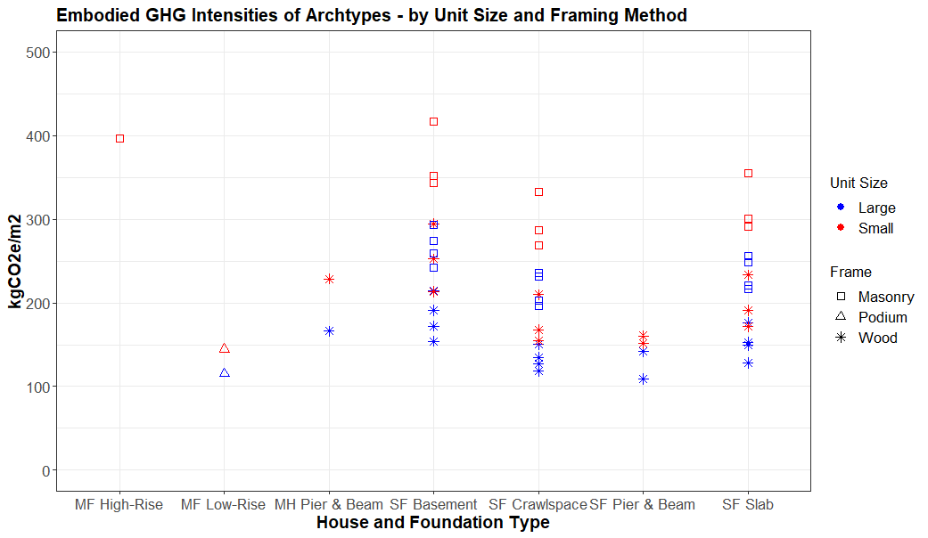

Figure S9 Variation in embodied GHG intensities of housing archetypes by house type, foundation, unit size, and framing method

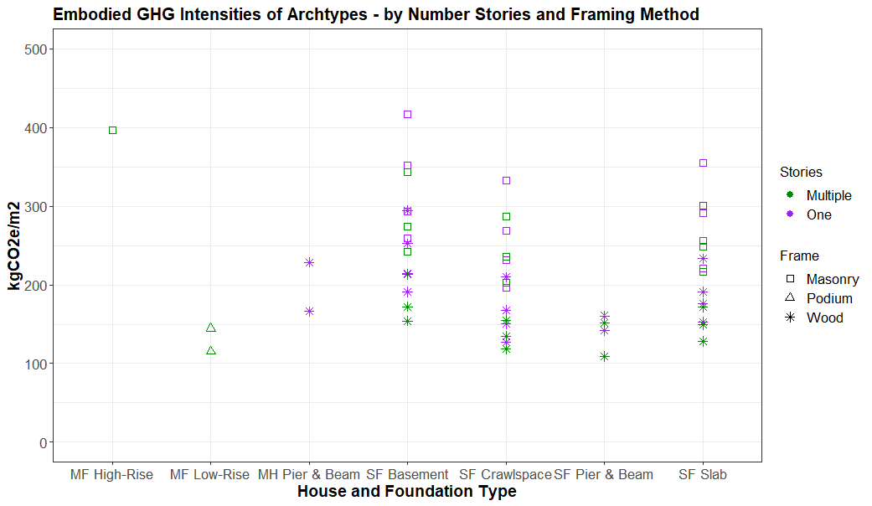

Figure S10 Variation in embodied GHG intensities of housing archetypes by house type, foundation, stories, and framing method

## Applying archetypes to housing stock model outputs

Here we describe our approach for applying archetype-specific material and GHG intensities to estimating total material inflows and outflows, and emissions associated with new construction, at the level of US counties.

A large 120,000-unit sample of new construction 2021-2060 was generated using Buildstock Batch (NREL, 2020a), which reflects the location and regionally-dependent characteristics of new housing built over the next four decades. The relative abundance of new construction in different locations is informed by the estimates of county level housing stock inflows from our housing stock model. The samples generated by Buildstock Batch incorporate regionally-dependent housing characteristics (including all of the dimensions used to define the archetypes in Table S6) which are based on various surveys and data sources, as described and used in ResStock (NREL, 2020b). Before designating each sample housing unit to an archetype, we expand the archetype definitions based on mixes of wood and masonry framing in new single-family homes per Census Division. For every single-family archetype with a wood-frame and masonry alternative (e.g. archetypes 1 and 8, 18 and 25, etc.), we define nine archetypes by calculating the weighted average material and GHG intensities and using the division share of wood-frame and masonry framing in new single family homes as the weighting factors (US Census Bureau, 2020b). This expands the number of archetypes to 270, or 30 archetype definitions for each Census Division. Apart from the Pacific Division where masonry accounts for 25%, 94-99% (depending on the Division) of new single family homes are wood-frame.

We next assign material and (2020 and 2060) GHG intensities to each housing unit in the sample representing new construction. We calculate mean material and GHG intensities for each county and housing type combination for which there are at least five observations. For combinations with fewer observations, intensities are defined based on state, or if necessary, Division averages. For each scenario, we calculate the total floorspace added in new construction each year in each county for each housing type by combining the number of housing units constructed according to the housing stock model. With this approach we reflect the local housing characteristics in in the estimates and material and GHG intensities of house types in each county. We apply the (per unit floor area) material and GHG intensities to the floor area construction flows to estimate total material requirements and GHG emissions each year. Material intensities are constant through 2020-2060, but the GHG intensities decline linearly from their 2020 to their 2060 values.

To calculate material outflows associated with demolition, we apply the same material intensity estimates by county and house type to the floor area outflows which are calculated using the number and type of housing units demolished, and the (cohort, type, and county-specific) average house size of houses being demolished. Applying the same material intensities to new housing and homes being demolished is a simplifying assumption, which disregards the likelihood that material intensities of new housing built today do not necessarily represent homes being demolished today. With the exception of insulation and glass, whose quantities are likely greater in new homes, we consider our archetypes to approximately represent both old and new housing, reflecting to a high level of detail the differences in material intensity that arise from the mix of archetypes that exist in different regions. We consider that much greater uncertainty regarding material inflows and outflows comes from the conversion of housing additions to new construction, and housing losses to demolition, which in our model are based on estimates informed by the historical rates shown in Table S2 and Table S3. Finally, the quantity of materials leaving the housing stock through demolition each year is in fact just a first requirement for estimating the potential for material and/or component reuse. To demonstrate the actual potential for material recycling would require additional consideration of material capture, processing, and admixture rates (Schiller, Gruhler, & Ortlepp, 2017), which is beyond the current scope, but would be a logical extension of this work.

## Additional Figures

In Figure S11 We provide additional detail on the ‘Results Processing’ module of the modelling approach (main manuscript Figure 1). Each box shows the units of the equation using each variable which is used as an input to the box. In the following bullet points we describe the results processing steps to calculate outputs of floor area per capita, materials flows from demolition and new construction, and GHG emissions from new construction.

* Stock additions [Housing Units] is multiplied by the percent of additions that come from new construction to calculate the number of newly construction housing units
* New construction [Housing Units] is multiplied by the average floor area per housing unit [m2/Unit] to calculate total floor area of new construction.
* Floor area of new construction [m2] is multiplied archetype-specific material intensity values [kg/m2] to calculate mass of materials required for new construction.
* Mass of materials for new construction [kg] is multiplied by GHG intensity values per material [kgCO2e/kg] to calculate GHG emissions from materials. This is added to GHG emissions from transport and construction energy use calculated as by multiplying floor area of new construction [m2] by transport/construction energy GHG intensity [kgCO2e/m2] in order to calculate total GHG emissions from new construction.
* Stock losses [Housing Units] is multiplied by the percent of losses that come from demolition to calculate the number of demolished housing units.
* Demolition [Housing Units] is multiplied by the average floor area per housing unit [m2/Unit] to calculate total floor area of demolition.
* Floor area of demolition [m2] is multiplied archetype-specific material intensity values [kg/m2] to calculate mass of materials associated with demolition
* The total occupied (*v*=0) housing stock [Housing Units] is multiplied by the average floor area per housing unit [m2/Unit] to calculate total stock of occupied floor area.
* Total occupied floor area [m2] is divided by population [Pop] to calculate floorspace per capita

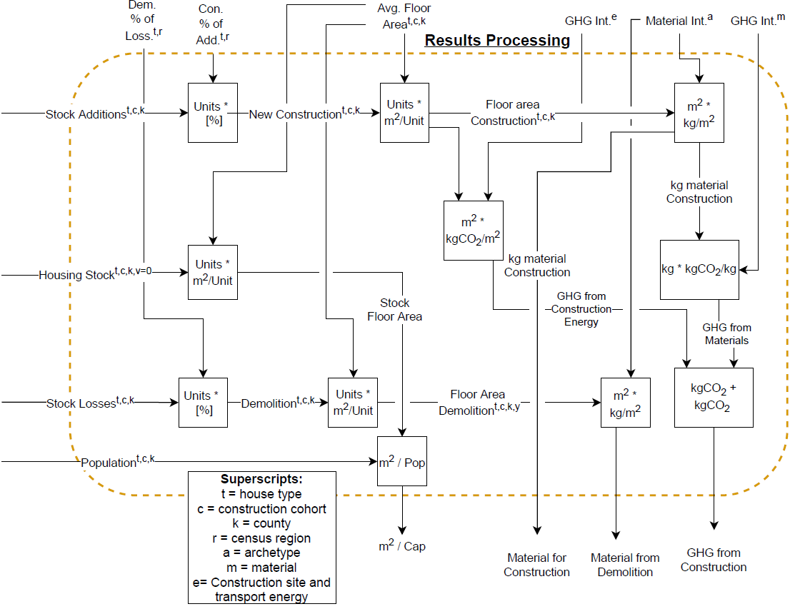

Figure S11 Detailed description of the ‘Results Processing’ module of the modeling appraoch

In Figure S12 we show rates of stock additions and losses for the four demonstration counties. Figure S13 shows fluctuations in vacancy rates by house type for selected counties in the *Baseline* scenario, demonstrating that in strong growth counties such as Harris, TX, vacancies can revert to natural rates quite quickly, while the evolution of vacancies is less predictable in declining counties, with the possibility for large increases in vacancy rates in strongly declining counties. Figure S14 shows mean floor area by type in scenarios with (5-6) and without (1-4) reduced floor area. In reduced floor area scenarios there is little difference in the average size of new multifamily and manufactured homes, but the average size of new single-family reduces from 258m2 to 193m2, a 25% reduction. Figure S15 shows differences in floor area distributions by house type in scenarios 1 (also represents scenario 2), 3 (also represents scenario 4), 5, and 6. Table S8 shows the conversion of floor area bins shown in Figure S15 from units sqft to m2.

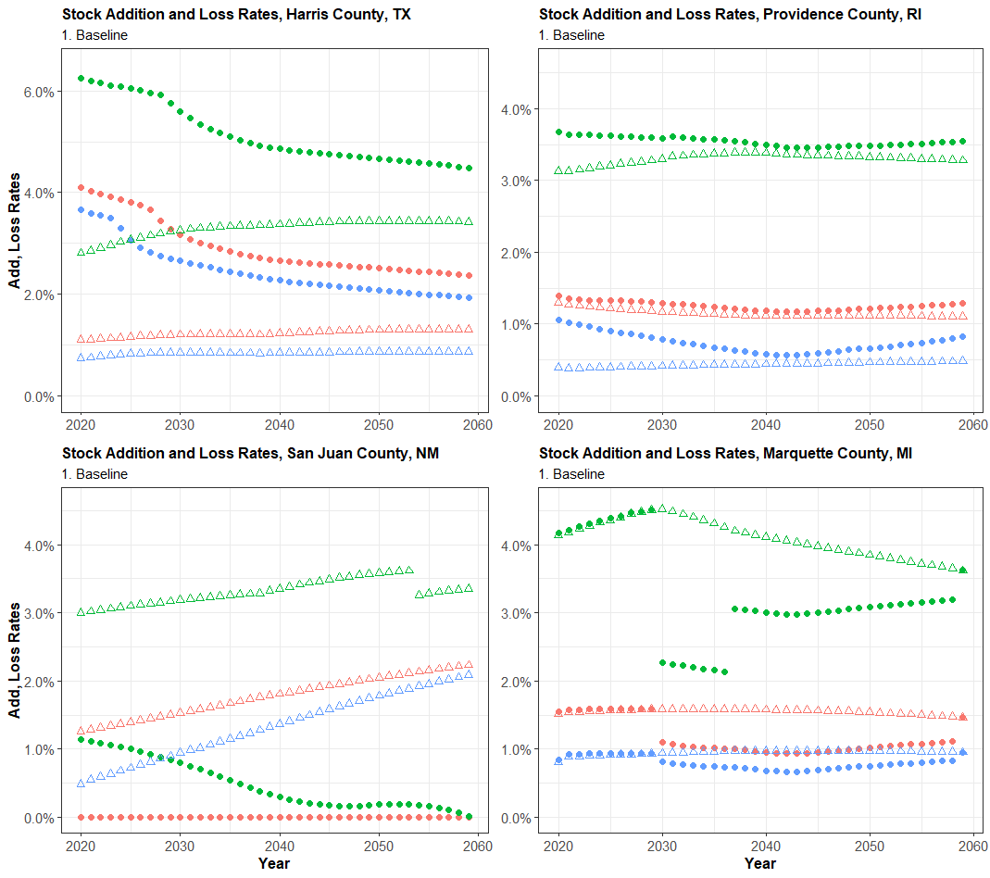 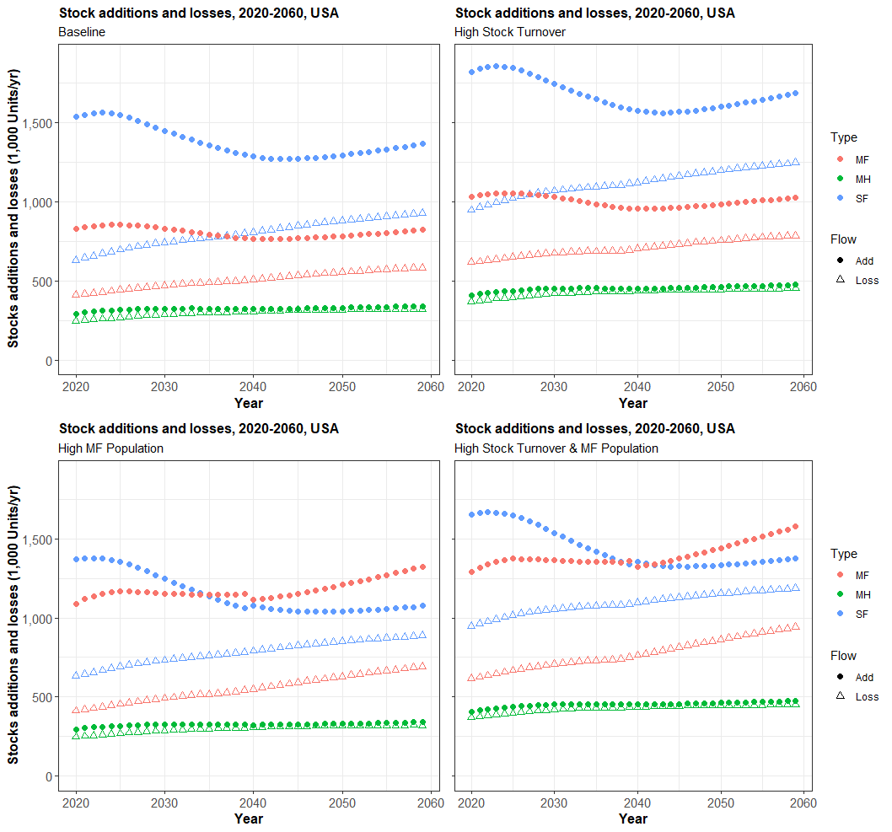

Figure S12 Stock addition and loss rates for four counties in the Baseline scenario. Different y-axis used for Harris County, TX.

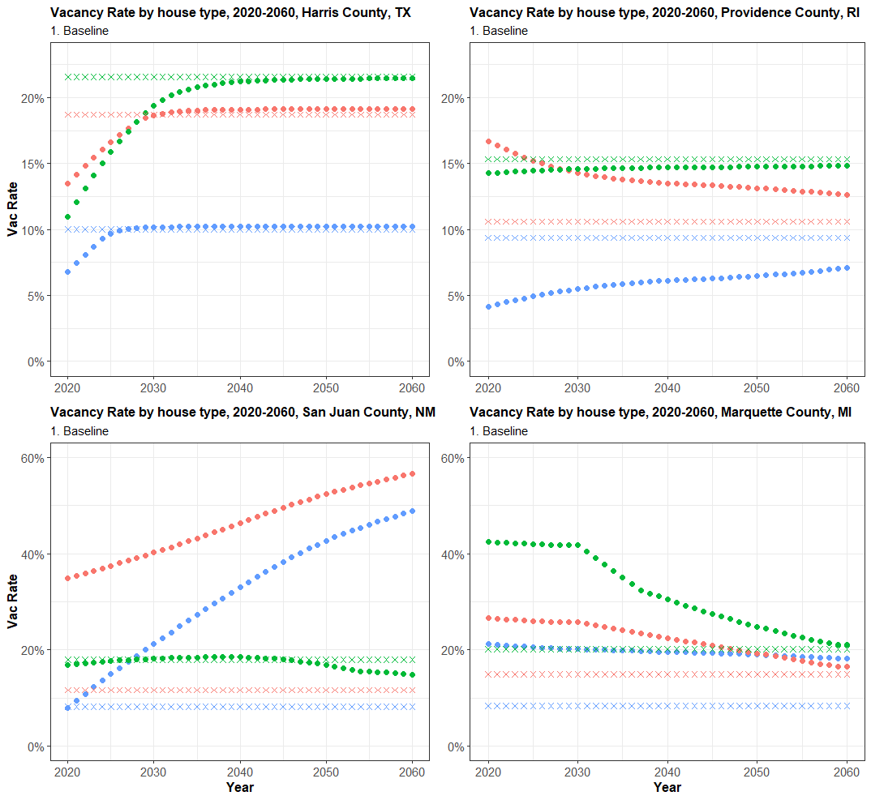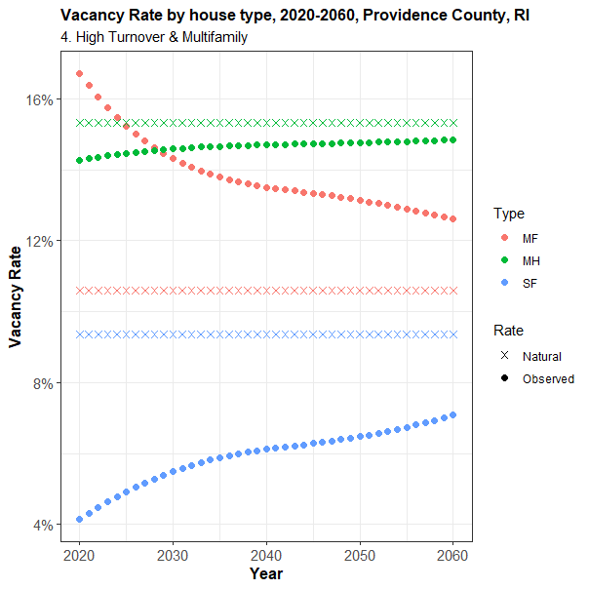

Figure S13 Vacancy Rate for seclected counties with diverging population trajectories, baseline scenario

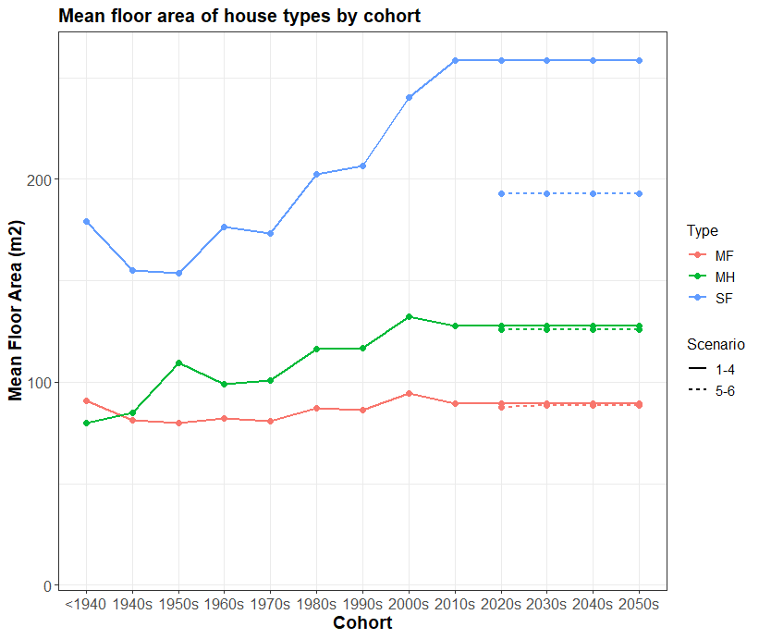

Figure S14 Mean Floor area by type, cohort, and scenario. Scenarios 5-6 are scenarios in which reduced floor area is implemented

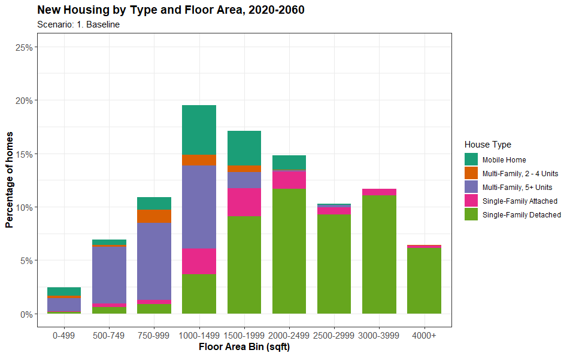

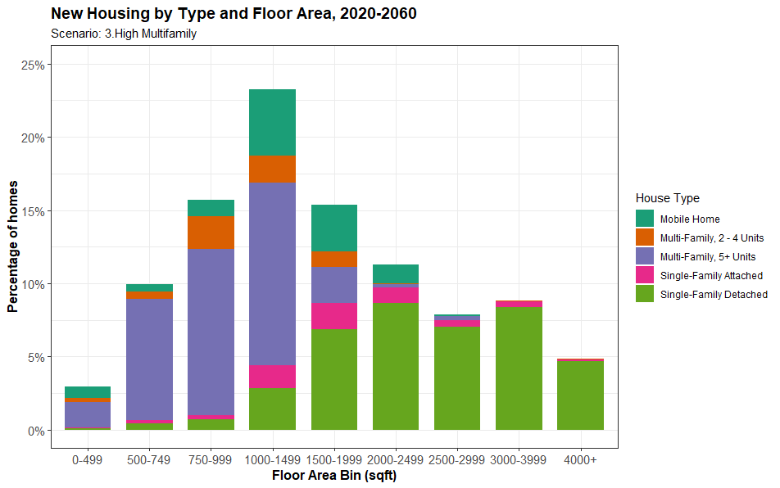

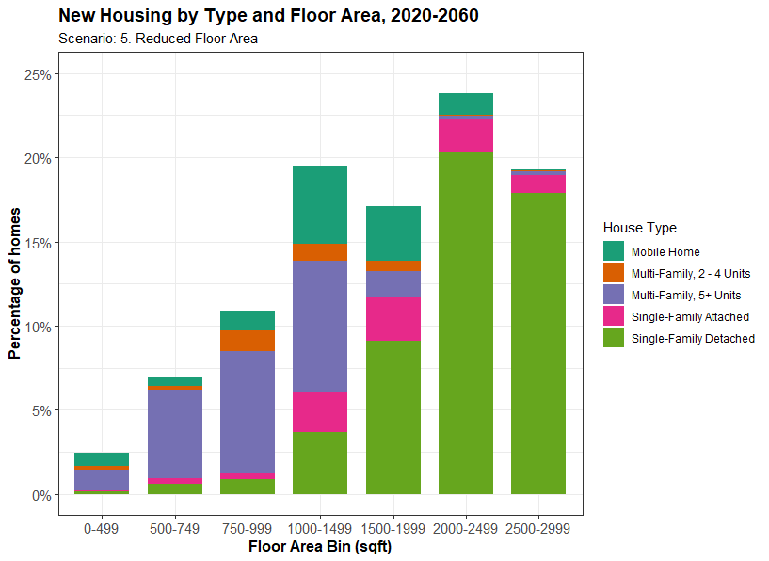 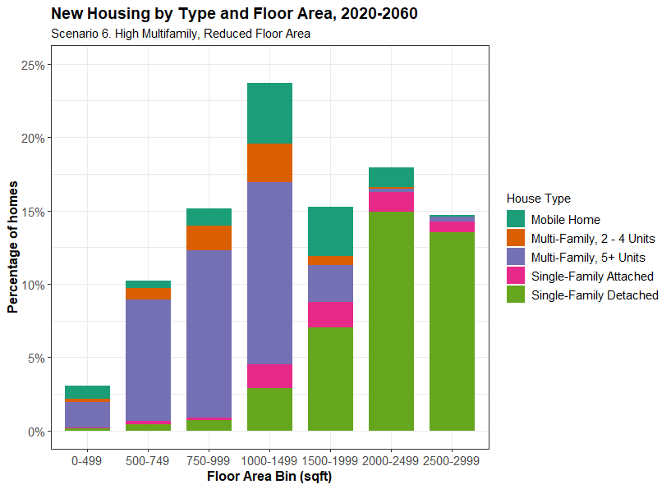

Figure S15 Floor area distributions by house type for scenarios 1, 3, 5, and 6. See Table S8 to convert floor area bins in sqft to m2

Table S8 Correspondence of floor area bins between sqft and m2

|  |  |
| --- | --- |
| **Floor Area Bin (sqft)** | **Floor Area Bin (m2)** |
| 0-499 | 0-46.3 |
| 500-749 | 46.4-69.6 |
| 750-999 | 69.7-92.8 |
| 1,000-1,499 | 92.9-139.2 |
| 1,500-1,999 | 139.3-185.7 |
| 2,000-2,499 | 185.8-232.1 |
| 2,500-2,999 | 232.2-278.6 |
| 3,000-3,999 | 278.7-371.5 |
| 4,000+ | 371.6+ |

Figure S16 shows annual GHG emissions from new construction each year 2020-2060, broken into 10 summary material categories, and emissions from site transport and energy use. Figure S17 shows annual material requirements for new construction each year 2020-2060, broken into 10 summary material categories. Concrete is by far the most prominent material in terms of total mass, followed by sand/aggregate, and wood. For GHG emissions, fibreglass, concrete, site transport and energy, steel and cement are the largest contributors.

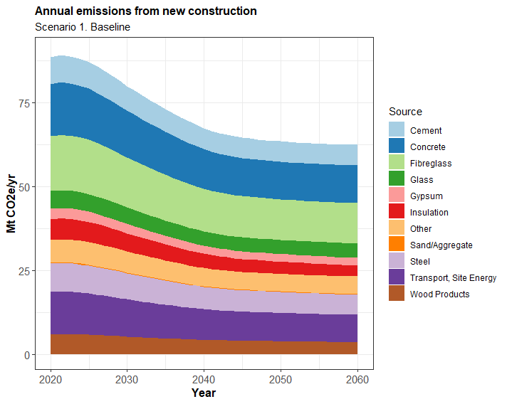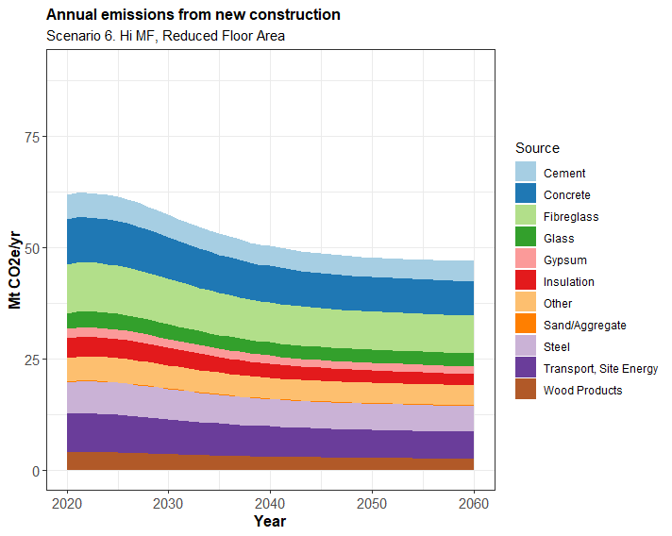

Figure S16 GHG emissions embodied in new construction, by aggregated material category, for scenarios 1 and 6

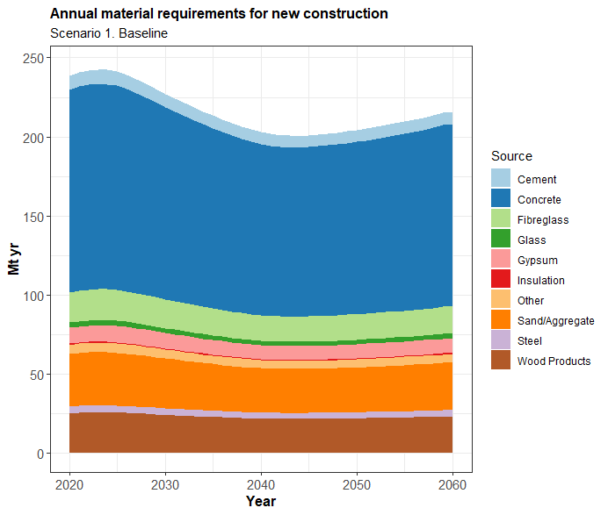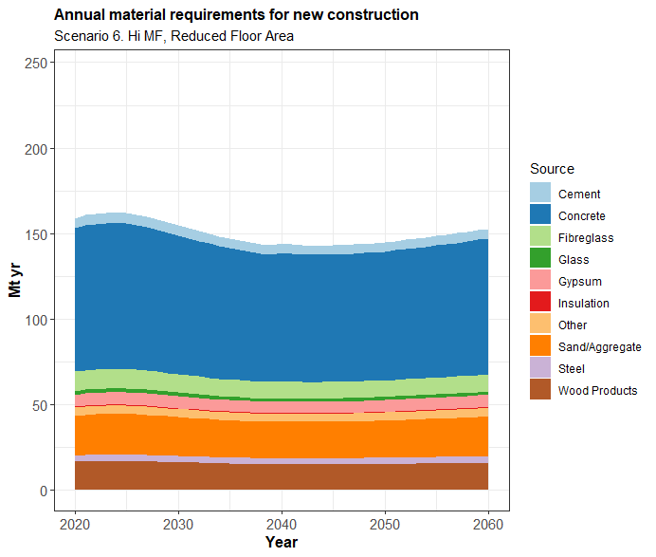

Figure S17 Material requirements for new construction, by aggregated material category, for scenarios 1 and 6

In Figures S18-S20 we show the ratio of material coming out of the housing stock through demolition to the material required for new construction for concrete, steel, and all materials, in 2020, 2030, 2040, and 2050. This ratio clearly increases over time as the growth of the housing stock slows, but materials continue to come out of the housing stock from demolition. The ratio of waste to required materials is most evident in particular regions, including the lower Mississippi basin, parts of the rural West, central Appalachia, and many parts of the Midwest and Northeast.

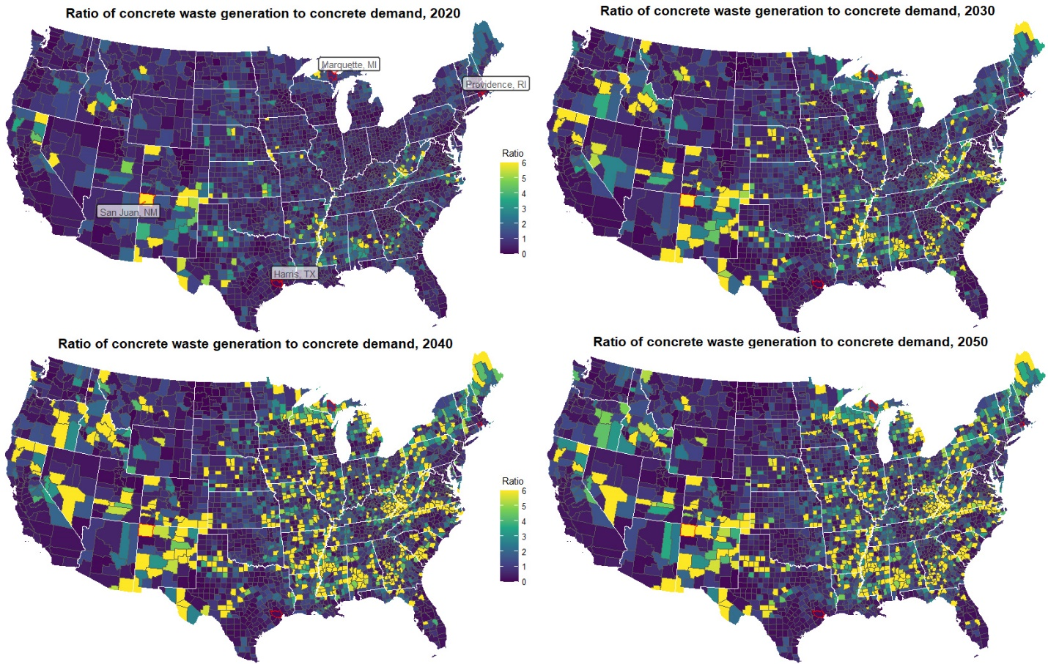

Figure S18 Ratio of concrete outflows to concrete inflows from housing demolition and construction in 2020, 2030, 2040, and 2050

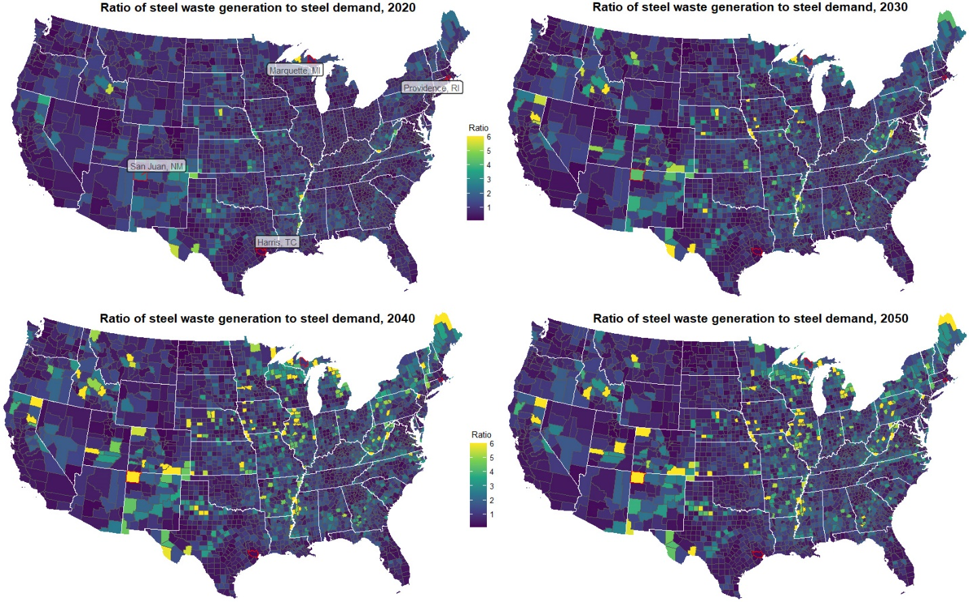

Figure S19 Ratio of steel outflows to steel inflows from housing demolition and construction in 2020, 2030, 2040, and 2050

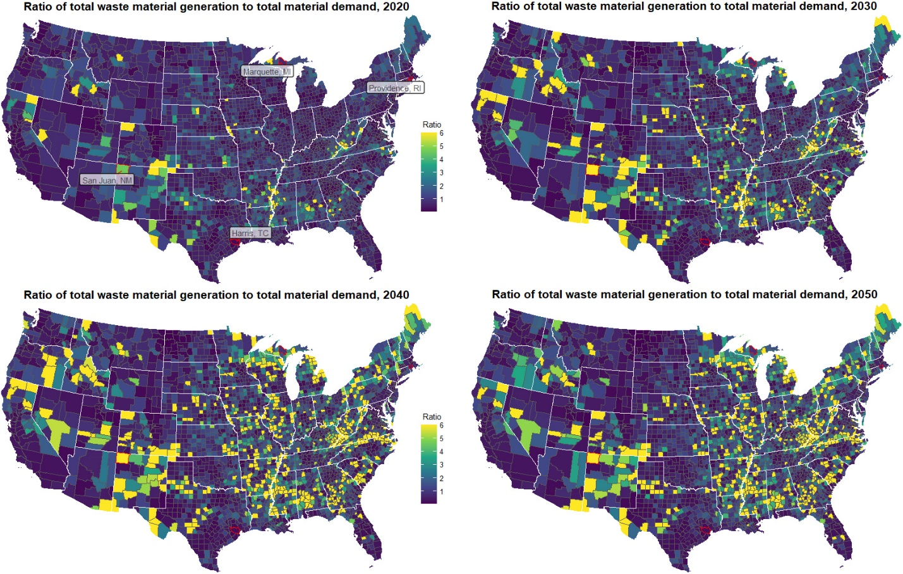

Figure S20 Ratio of outflows to inflows for all materials from housing demolition and construction in 2020, 2030, 2040, and 2050

Figure S21 demonstrates for all scenarios the growth of these ratios at a national level for three individual materials and all materials. In all scenarios there is a growth in the ratio of waste to required materials, particularly between 2020 and 2040. After 2040 the ratios level off or grow much more slowly, depending on the scenario. These ratios, like the floor area inflows shown in Figure 5(a) of the main manuscript, are strongly influenced by the rate of population and housing stock growth, which decline to mid 2040s before picking up again between 2050 and 2060 (Figure S1, main manuscript Figure 2(b)). The pace of housing growth slightly outpaces population growth, due to declining household size.

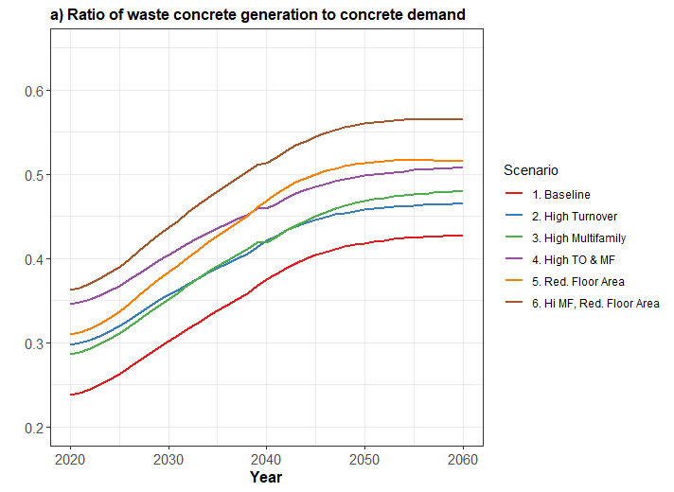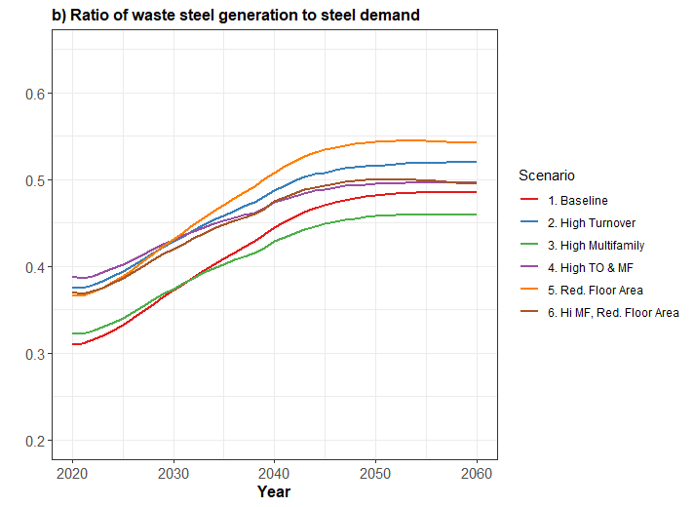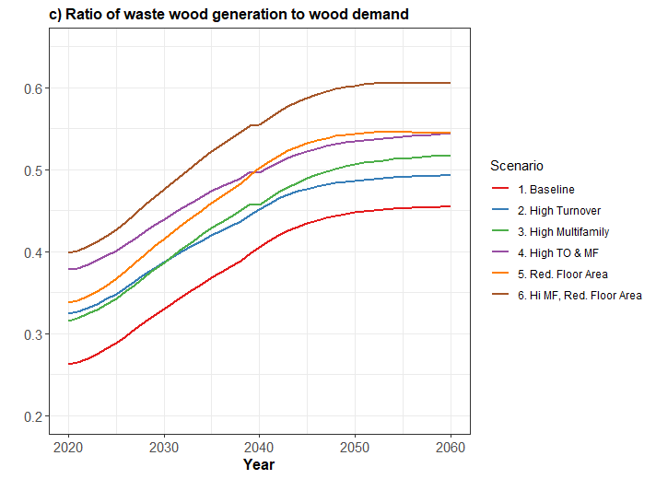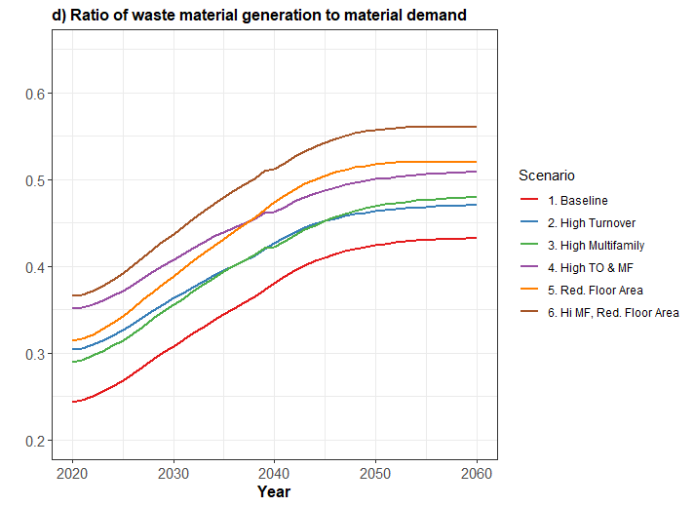

Figure S21 National ratio of waste material to material demand for concrete, steel, wood, and all materials in six housing stock and characteristics scenarios

Figure S22 shows the progression of county level vacancy rates in 2020, 2030, 2040, and 2050, for all house types combined. Vacancy rates are bottom-coded at 5% and top-coded at 40% to increase the visibility of variation between counties within this range. In many counties with high vacancy rates in 2020, vacancies actually decrease, and the number of counties with vacancy rates of 40% of above decreases from X in 2020 to Y in 2050. This is an outcome of our housing stock model equations, which move vacancies towards the natural rate in growing counties, and limit construction in declining counties. Housing stock loss rates are also much higher for vacant housing units (Table S1), which increases the housing stock losses in counties with high vacancy rates, which will tend to reduce vacancy rates.

Figure S22 Vacancy rate by county for all house types in 2020, 2030, 2040, and 2050, all rates are from baseline scenario 1

Figure S23 shows the evolution of vacancy rates by house type at the national level, 2020-2060 for each housing stock scenario. In scenarios *without* high stock turnover (1, 3, 5, 6), single-family and multifamily vacancy rates increase slightly. This is probably related to increases in vacancy rates towards natural rates in high-population counties with sub-natural vacancy rates, such as Harris, TX; Los Angeles, CA; New York, NY, etc. In high stock turnover scenarios (2, 4) the higher loss rates supress the growth of vacancy rates.

Figure S23 National vacancy rates by house types for each housing stock scenario, 2020-2060

In Figure S24 we show floor area per capita for all counties in 2020 and 2050 in the *Baseline* scenario. This demonstrates the geographic variability, highlighting some regions such as the upper Midwest and some counties in Colorado and Virginia which have particularly high floor area consumption. There is also a clear increase in floor area per capita between 2020 and 2050, corresponding with the national level trend shown in Figure 4 of the main manuscript.

Figure S24 Floor area per capita for all counties in the Baseline scenario in 2020 and 2050.

# References

Athena Sustainable Materials Institute. (2020). *Athena Impact Estimator v5.4*. https://calculatelca.com/software/impact-estimator/

Cao, L. (2019, November 29). Putting Wood on a Pedestal: The Rise of Mid-Rise Podium Design. *Arch Daily*. https://www.archdaily.com/927592/putting-wood-on-a-pedestal-the-rise-of-mid-rise-podium-design

Concrete Network. (n.d.). *Concrete Footing Size & Dimensions*. Retrieved March 17, 2021, from https://www.concretenetwork.com/concrete/footing_fundamentals/footing_dimensions.htm

Dahlstrøm, O., Sørnes, K., Eriksen, S. T., & Hertwich, E. G. (2012). Life cycle assessment of a single-family residence built to either conventional- or passive house standard. *Energy and Buildings*, *54*, 470–479. https://doi.org/10.1016/j.enbuild.2012.07.029

Fannie Mae. (2021). *Selling Guide, B4-1.3-05, Improvements Section of the Appraisal Report*. https://selling-guide.fanniemae.com/Selling-Guide/Origination-thru-Closing/Subpart-B4-Underwriting-Property/Chapter-B4-1-Appraisal-Requirements/Section-B4-1-3-Appraisal-Report-Assessment/1032992541/B4-1-3-05-Improvements-Section-of-the-Appraisal-Report-09

Fox, J. (2019, February 13). Why America’s New Apartment Buildings All Look The Same. *Bloomberg Businessweek*. https://www.bloomberg.com/news/features/2019-02-13/why-america-s-new-apartment-buildings-all-look-the-same

Hauer, M. E. (2019). Population projections for U.S. counties by age, sex, and race controlled to shared socioeconomic pathway. *Scientific Data*, *6*, 1–15. https://doi.org/10.1038/sdata.2019.5

Heeren, N., Mutel, C. L., Steubing, B., Ostermeyer, Y., Wallbaum, H., & Hellweg, S. (2015). Environmental Impact of Buildings - What Matters? *Environmental Science and Technology*, *49*(16), 9832–9841. https://doi.org/10.1021/acs.est.5b01735

Hester, J., Miller, T. R., Gregory, J., & Kirchain, R. (2018). Actionable insights with less data: guiding early building design decisions with streamlined probabilistic life cycle assessment. *The International Journal of Life Cycle Assessment*. https://doi.org/10.1007/s11367-017-1431-7

Holladay, M. (2014, August). Insulating a Slab-On-Grade Foundation. *Fine Homebuilding*. https://www.finehomebuilding.com/2014/07/09/insulating-a-slab-on-grade?

Model Manufactured Home Installation Standards, Subpart D - Foundations, (2001). http://www.versuslaw.com/cfr/24cfr/24cfr=24cfr03285@284751.01596.asp

Jones, C. (2019). *Inventory of Carbon and Energy (ICE) V3.0*. https://circularecology.com/embodied-carbon-footprint-database.html

Lenzen, M., Gallego, B., & Wood, R. (2009). Matrix balancing under conflicting information. *Economic Systems Research*, *21*(1), 23–44. https://doi.org/10.1080/09535310802688661

Manufactured Housing Research Alliance. (2002). *Guide to Foundation and Support*. https://www.huduser.gov/portal/publications/destech/foundations.html

McCue, D. (2018). *Updated Household Growth Projections: 2018-2028 and 2028-2038*. https://www.jchs.harvard.edu/sites/default/files/Harvard_JCHS_McCue_Household_Projections_Rev010319.pdf

Moncaster, A. M., Pomponi, F., Symons, K. E., & Guthrie, P. M. (2018). Why method matters: Temporal, spatial and physical variations in LCA and their impact on choice of structural system. *Energy and Buildings*, *173*, 389–398. https://doi.org/10.1016/j.enbuild.2018.05.039

Nadoushani, Z. S. M., & Akbarnezhad, A. (2015). Effects of structural system on the life cycle carbon footprint of buildings. *Energy & Buildings*, *102*, 337–346. https://doi.org/10.1016/j.enbuild.2015.05.044

NREL. (2020a). *BuildStock Batch v0.18*. https://buildstockbatch.readthedocs.io/en/latest/

NREL. (2020b). *ResStock Housing Characteristics*. ResStock v2.3.0. https://github.com/NREL/OpenStudio-BuildStock/tree/master/project_national/housing_characteristics

Oak Ridge National Laboratory. (2013). *Foundation Design Handbook*. https://foundationhandbook.ornl.gov/handbook/

Petrovic, B., Myhren, J. A., Zhang, X., Wallhagen, M., & Eriksson, O. (2019). Life cycle assessment of a wooden single-family house in Sweden. *Applied Energy*, *251*(May), 113253. https://doi.org/10.1016/j.apenergy.2019.05.056

Quale, J., Eckelman, M. J., Williams, K. W., Sloditskie, G., & Zimmerman, J. B. (2012). Construction Matters: Comparing Environmental Impacts of Building Modular and Conventional Homes in the United States. *Journal of Industrial Ecology*, *16*(2), 243–253. https://doi.org/10.1111/j.1530-9290.2011.00424.x

Reyna, J. L., & Chester, M. V. (2015). The Growth of Urban Building Stock: Unintended Lock-in and Embedded Environmental Effects. *Journal of Industrial Ecology*, *19*(4), 524–537. https://doi.org/10.1111/jiec.12211

Säynäjoki, A., Heinonen, J., Junnonen, J. M., & Junnila, S. (2017). Input–output and process LCAs in the building sector: are the results compatible with each other? *Carbon Management*, *8*(2), 155–166. https://doi.org/10.1080/17583004.2017.1309200

Schiller, G., Gruhler, K., & Ortlepp, R. (2017). Continuous Material Flow Analysis Approach for Bulk Nonmetallic Mineral Building Materials Applied to the German Building Sector. *Journal of Industrial Ecology*, *21*(3), 673–688. https://doi.org/10.1111/jiec.12595

US Census Bureau. (2017a). *2017 National Population Projections Tables Projections for the United States: 2017 to 2060*. https://www.census.gov/data/tables/2017/demo/popproj/2017-summary-tables.html

US Census Bureau. (2017b). *Definitions and Explanations*. Annual Statistics 2017. https://www.census.gov/housing/hvs/files/annual17/ann17def.pdf

US Census Bureau. (2017c). *Sample Case History*. American Housing Survey. https://www.census.gov/programs-surveys/ahs/tech-documentation/help-guides/national-sample-case-history.html

US Census Bureau. (2020a). *American Housing Survey*.

US Census Bureau. (2020b). *Characteristics of New Housing*. Survey of Construction. https://www.census.gov/construction/chars/

US Census Bureau. (2020c). *County Population Totals: 2010-2019*. https://www2.census.gov/programs-surveys/popest/tables/2010-2019/counties/totals/co-est2019-annres.xlsx

US Census Bureau. (2020d). *National Population Totals: 2010-2020*. Vintage 2020 Population Estimates. https://www.census.gov/programs-surveys/popest/technical-documentation/research/evaluation-estimates/2020-evaluation-estimates/2010s-totals-national.html

US Census Bureau. (2021). *American Community Survey Data*. American Community Survey. https://www.census.gov/programs-surveys/acs/data.html

Wernet, G., Bauer, C., Steubing, B., Reinhard, J., Moreno-Ruiz, E., & Weidema, B. (2016). The ecoinvent database version 3 (part I): overview and methodology. *International Journal of Life Cycle Assessment*, *21*(9), 1218–1230. https://doi.org/10.1007/s11367-016-1087-8